Name : Khushi Panwar

Roll No : 2021334

SEC (Python) PRACTICAL ASSIGNEMENT : 22.09.2022

Computer Science (3rd Sem)

**Question 4 (From Practical List ) :**

**Solution 🡪**

def createSet():

num=input("\nEnter the number here : ")

lst=[int(x) for x in str(num)]

if (float(num)>=10):

setDigit=set()

for i in lst:

setDigit.add(i)

return setDigit

else:

print(" ERROR : INVALID NUMBER ! Try again ")

creatSet()

print("QUES 4 : This program inputs a number and returns its digits in a set!")

result=createSet()

print()

print("-> The Set Formed : ", result)

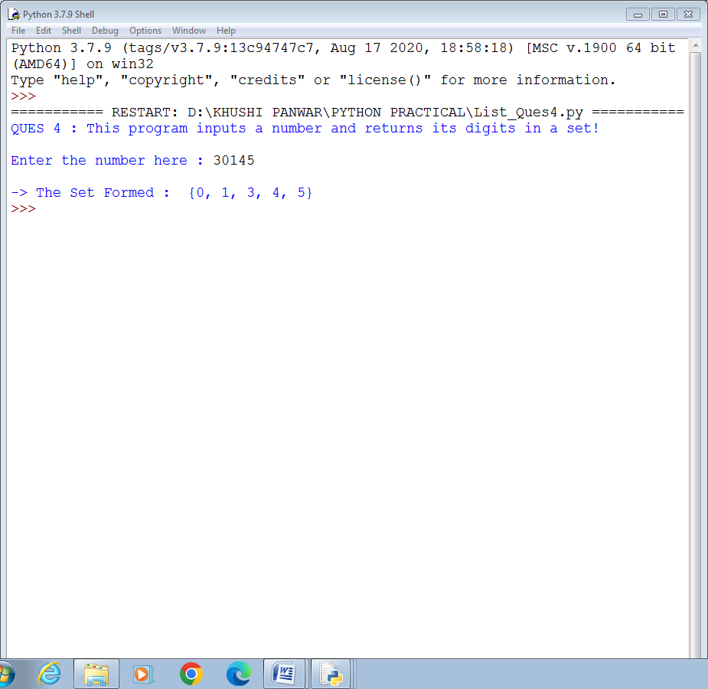

**Extra Ques : WAP that take input the number of rows and prints the following patterns in output!**

def pattern_1(rows):

print("\n\t\t\t ********* PATTERN A ******** ")

for i in range(1, rows+1):

for j in range(1,i+1):

print(j, "\t", end="")

print()

def pattern_2(rows):

print("\n\t\t\t ********* PATTERN B ******** ")

k=flag1=flag2=0

for i in range(1, rows+1):

for space in range(1,(rows-i)+1):

print(" ", end="")

flag1+=1

while k!=((2*i)-1):

if flag1<=rows-1:

print(i+k, end=" ")

flag1+=1

else:

flag2+=1

print(i+k-(2*flag2), end=" ")

k+=1

k=flag1=flag2=0

print()

def pattern_3(rows):

print("\n\t\t\t ********* PATTERN C ******** ")

for i in range(rows, 0,-1):

for j in range(i,0,-1):

print(j, "\t", end="")

print()

def pattern_4(rows):

print("\n\t\t\t ********* PATTERN D ******** ")

for i in range(1, rows+1):

for j in range(1,i+1):

print(i, "\t", end="")

print()

def pattern_5(rows):

print("\n\t\t\t ********* PATTERN E ******** ")

for i in range(0, rows):

print(" "*i, end="")

for j in range(i+1,rows+1):

print(j," ", end="")

print()

def pattern_6(rows):

print("\n\t\t\t ********* PATTERN F ******** ")

for i in range(1, rows+1):

if (i==1 or i==rows):

print("* "*rows)

else:

print("*"," "*4," *")

print("\n \t ** THIS PROGRAM GENERATES 6 DIFFERENT PATTERNS ** \n")

r=int(input("Enter the number of rows : "))

pattern_1(r)

pattern_2(r)

pattern_3(r)

pattern_4(r)

pattern_5(r)

pattern_6(r)

